Lab 1 Robot Control

Will Graham

Note: I had to take screenshots outside of lab, and I don’t’ have access to the Quanser quarc_library license. The titles are easy to read, so the thing still makes sense.

Simulink Model:



Open Loop Step Response

* Encoder counts were verified to be positive in the step response direction. If they weren’t the following questions wouldn’t have worked

Simulink Model



P = 0.75 Plots and Step Response Info



P = 1 Plots and Step Response Info

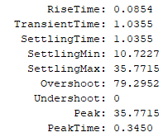

P = 2 Plots and Step Response Info

* What would I choose to optimize the response?
  + I’d choose the Kp = 0.75 response, as it does the best job of balancing a relatively low oscillation response with a low steady state error. If settling time is our main concern, then I’d choose Kp = 0.75. If steady state error is our primary concern then I’d choose a higher Kp.
  + Steady state error and step response is shown below each plot.

Simulink Model



PV Control with HW Gains Kp = 8.2 V = 0.27

PV Control with Tuned Gains Kp = 8.5 V = 0.3



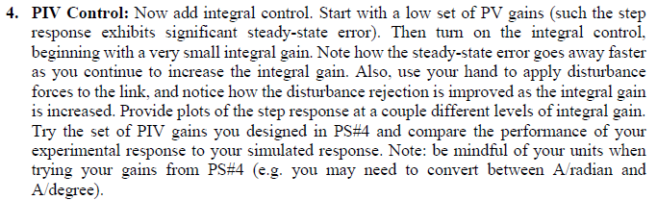

Simulink Model



PIV Control HW Gains Kp = 11.75, Ki = 97, V = 0.356



Experimental Gains Kp = 8.5 Kv = 0.3 Ki = 10



Experimental Gains Kp = 8.5 Kv = 0.3 Ki = 50

Experimental Gains Kp = 8.5 Kv = 0.3 Ki = 100



* Comparing
  + Clearly, the homework gains were by far better than the experimental gains we used. The higher our integral gain the higher our settling time and overshoot became, but we also achieved lower steady state errors. Interestingly our settling min didn’t seem to be affected much by higher or lower integral gains. That said, the overshoot was very different.